 |  | Quality Alert
For customer, written concern and significance supplier issue
Part name- Polycorbonate Sheet |  |  | QA
Customer/supplier name- |  |  | Issue Date: - 21/01/2023
Problem Description
Found damages on polycarbonate sheet at client location.
Defects Part Photograph
NOT OK PART | OK PART

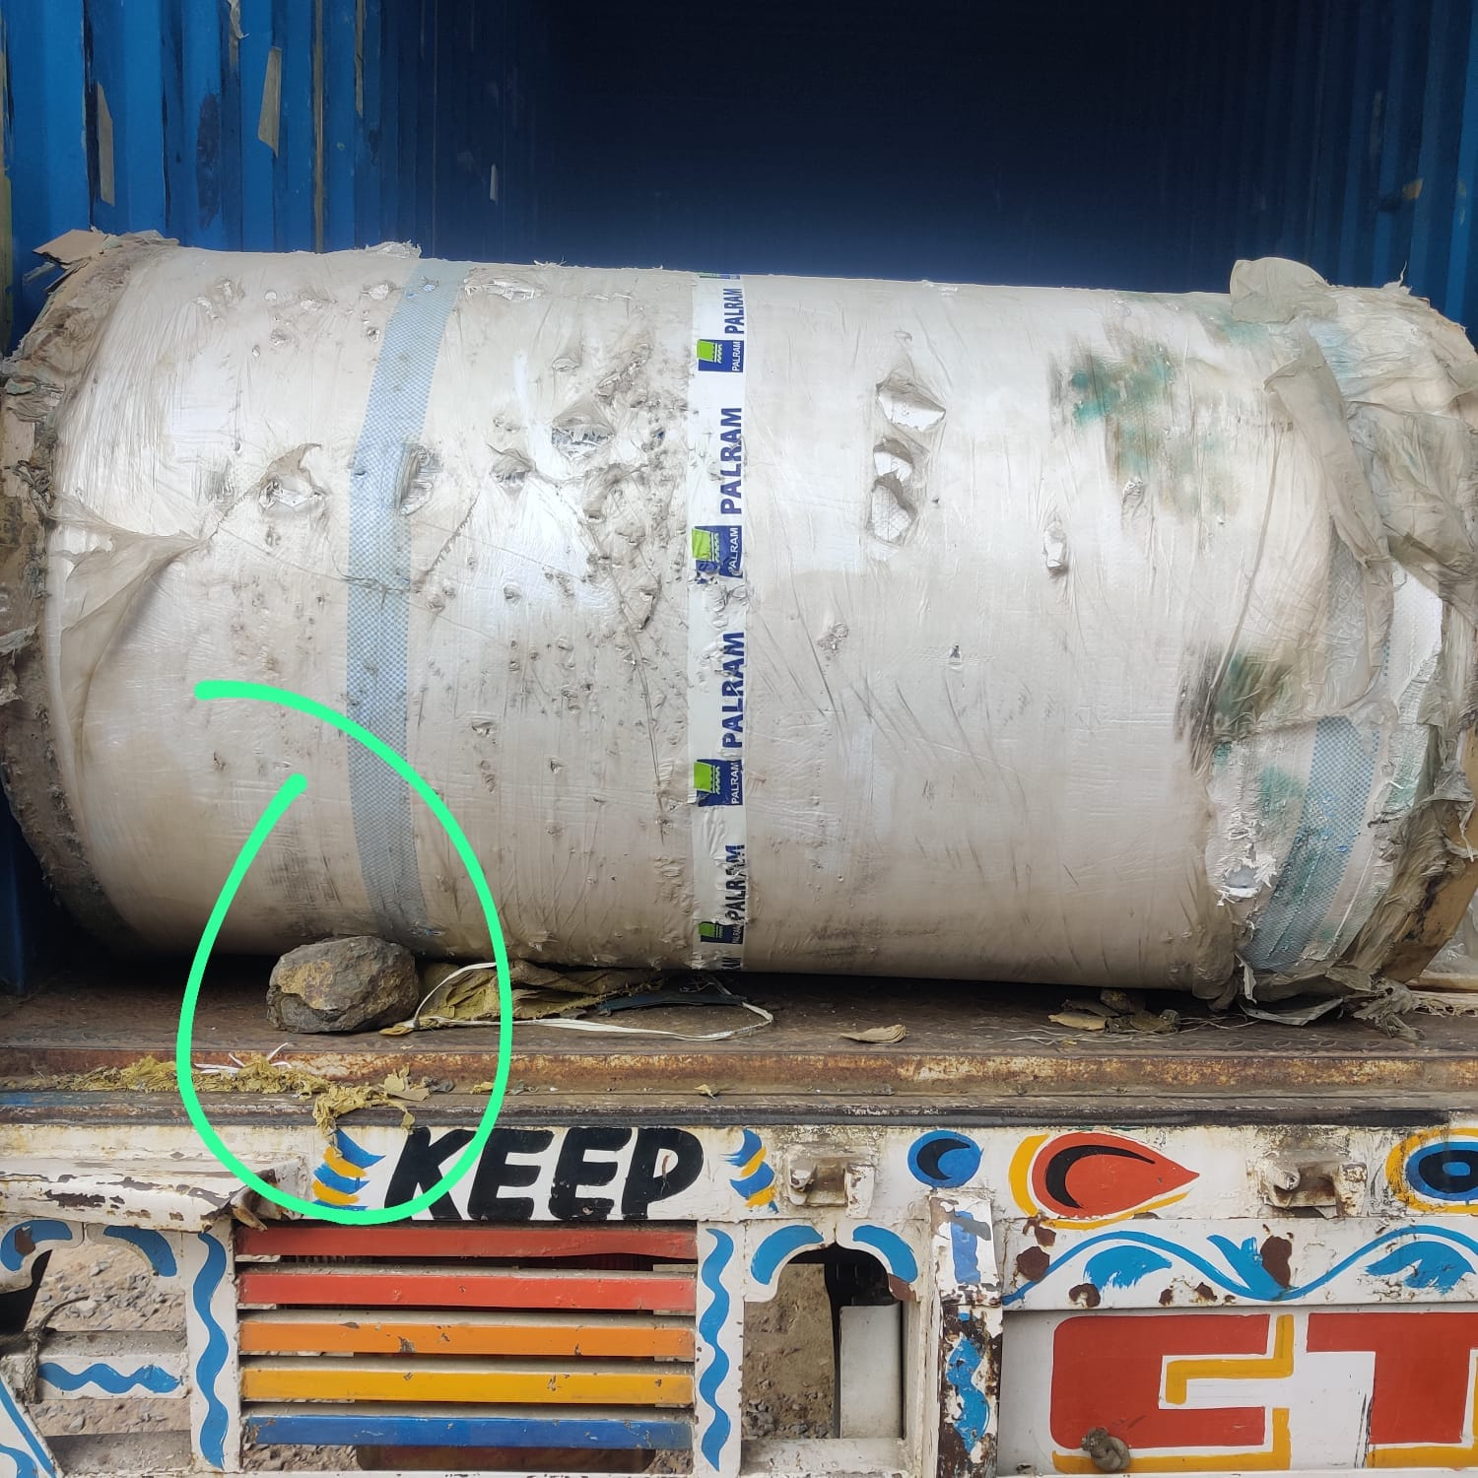
Unwanted Support
Prepared By:- Rohit Pawar |  |  | Approved By: - Amit kurhade

